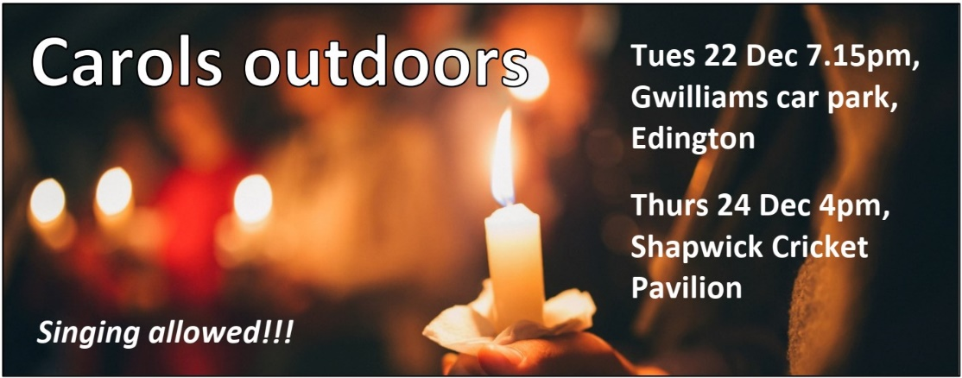
DECEMBER 2020
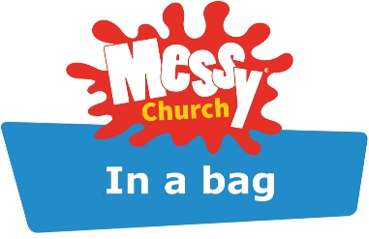
Messy Christmas online: Sat Dec 12 4pm. A goody bag provided for every child. To book, email Rich or Fiona (fi_mac_dan@yahoo.com).
Online nativity: Thurs Dec 24 5.45pm. For more details and to book, please email Rich or Jo (joprunier@yahoo.co.uk).
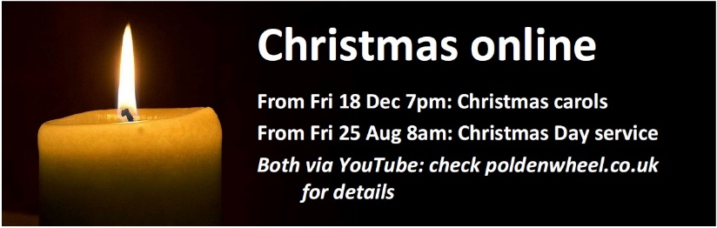
Hi folks,
This time last year, we could not have anticipated the extraordinary impact a virus would have on all of our lives – not just nationally, but globally. We’re therefore facing a strange and unique kind of Christmas, in which so much of what we regard as ‘normal’ is being stripped away.
We have all been impacted by the virus – either directly on ourselves or those close to us, or by the effects of the lockdowns. Although this has been difficult for almost all of us, for some it is particularly hard. For this reason, the Church of England has chosen a ‘Comfort and Joy’ theme, recognising that we won’t all feel ready for jubilation on Christmas morning this year.
As public worship is permitted this month, we will be able to have services on Christmas Day, as well as indoor carol services. Unfortunately, we won’t be able to sing, and we’ll be socially distanced. However, I’m delighted that we’ll be holding two outdoor Carol services, at which we are permitted to sing (see p1).
One bizarre consequence of the pandemic is that, while we normally try to make our churches warm and welcoming, this year we need to ensure that they are well-ventilated: therefore. everyone who comes should wrap up warmly.
We will therefore also be producing some events online, including a carol service and a Christmas Day service. There will also be a nativity for adults, ‘No inn at the room’, which is a historically-accurate dramatisation of the first Christmas. We also have some great events for children, as shown on page 1.
Perhaps this year, with so much of what’s normal to our experience of Christmas stripped away, we’ll be drawn more fully to the beauty and simplicity of the story of the birth of Jesus, the son of God.
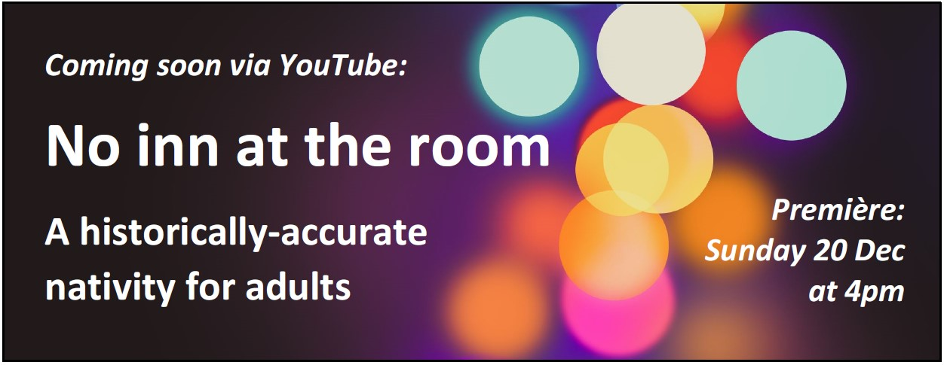
Wishing you all a very blessed Christmas!
Rich Tweedy (vicar@poldenwheel.co.uk)

Christmas Services 2020
Candlelit indoor carol services (music but no singing)
Friday 18 Dec 7pm Catcott
Saturday 19 Dec 7pm Burtle

Sunday 20 Dec 4pm Edington

Sunday 20 Dec 7pm Ashcott
An online carol service will be available via YouTube: premiere Friday 18 Dec at 7pm.
Outdoor carol services with singing
Tues 22 Dec 7:15pm Gwilliam’s car park
Thurs 24 Dec 4pm Shapwick Cricket Pavilion

Friday 25 Christmas Day
From 8:00am – an online service available via YouTube
9.00am Communion Edington
9.00am Communion Ashcott
9.30am Communion Burtle
10.30am Communion Catcott
10.30am Informal Worship Shapwick
All our churches now have limited capacity in order to observe social distancing regulations. To guarantee your place, please book through your churchwardens (see below).
Churchwardens

All Saints, Ashcott: Margaret Trimm 01458 210448
St. Philip & St James, Burtle: Alison Everett 01278 723736
St Peter’s, Catcott: Martin Melia 01278 722808
St Edward’s, Chilton Polden: Anne Lush 01278 722408
St George’s, Edington: Rosie Tilbury 01278 722208
St Mary’s, Shapwick: Rosemary Hargreaves 01458 210533
Important Information about all our church services
Unfortunately, due to the Covid-19 restrictions, all churches will be well ventilated so please wear warm clothing when you come.
Masks must be worn and there will be no singing.

Regular Church Services in December 2020

Sunday 6 December – 2nd Sunday of Advent
9.30 Catcott Holy Communion
11.00 Informal Worship online via Zoom

Sunday 13 December – 3rd Sunday of Advent
9.30 Ashcott Holy Communion
11.00 Informal Worship online via Zoom

Sunday 20 December – 4th Sunday of Advent
9.30 Shapwick Holy Communion
11.00 Informal Worship online via Zoom
Sunday 27 December – 1st Sunday after Christmas
9.30 Edington Holy Communion
11.00 No service via Zoom

Sunday 3 January – Epiphany 1
9.30 Burtle Holy Communion
11.00 Informal Worship online via Zoom

Sunday 10 January – Epiphany 2
9.30 Chilton Polden Holy Communion
11.00 Informal Worship online via Zoom
Would you like to access our Zoom services but haven’t done so before? Email Rich, or visit the Polden Wheel website and complete the online form on the home page. You will then be added to the list for future services.

Sunday Readings for December
6 Dec: Isaiah 40.1-11; Psalm 85.1-2,8-13; 2 Peter 3.8-15a; Mark 1.1-8
13 Dec: Isaiah 61.1-4,8-end; Psalm 126; 1 Thess. 5.16-24; John 1.6-8,19-28
20 Dec:2 Samuel 7.1-11,16; Psalm 89.1-4,19-26; Romans 16.25-end; Luke 1.26-38
3 Jan: Jeremiah 31.7-14; Psalm 147.13-end; Ephesians 1.3-14; John 1.(1-9) 10-18
10 Dec: Isaiah 60.1-6; Psalm 72 (1-9)10-15; Ephesians 3.1-12; Matt.2.1-12

Other Church Contacts

Vicar: Rev Rich Tweedy 01458 210260
vicar@poldenwheel.co.uk: Day off Friday
Parish Administrator: Sue Ball (Office hours: Tues – Thurs 10am – 2pm)
admin@poldenwheel.co.uk
PCC Treasurer: Brian Tilbury 01278 722208

